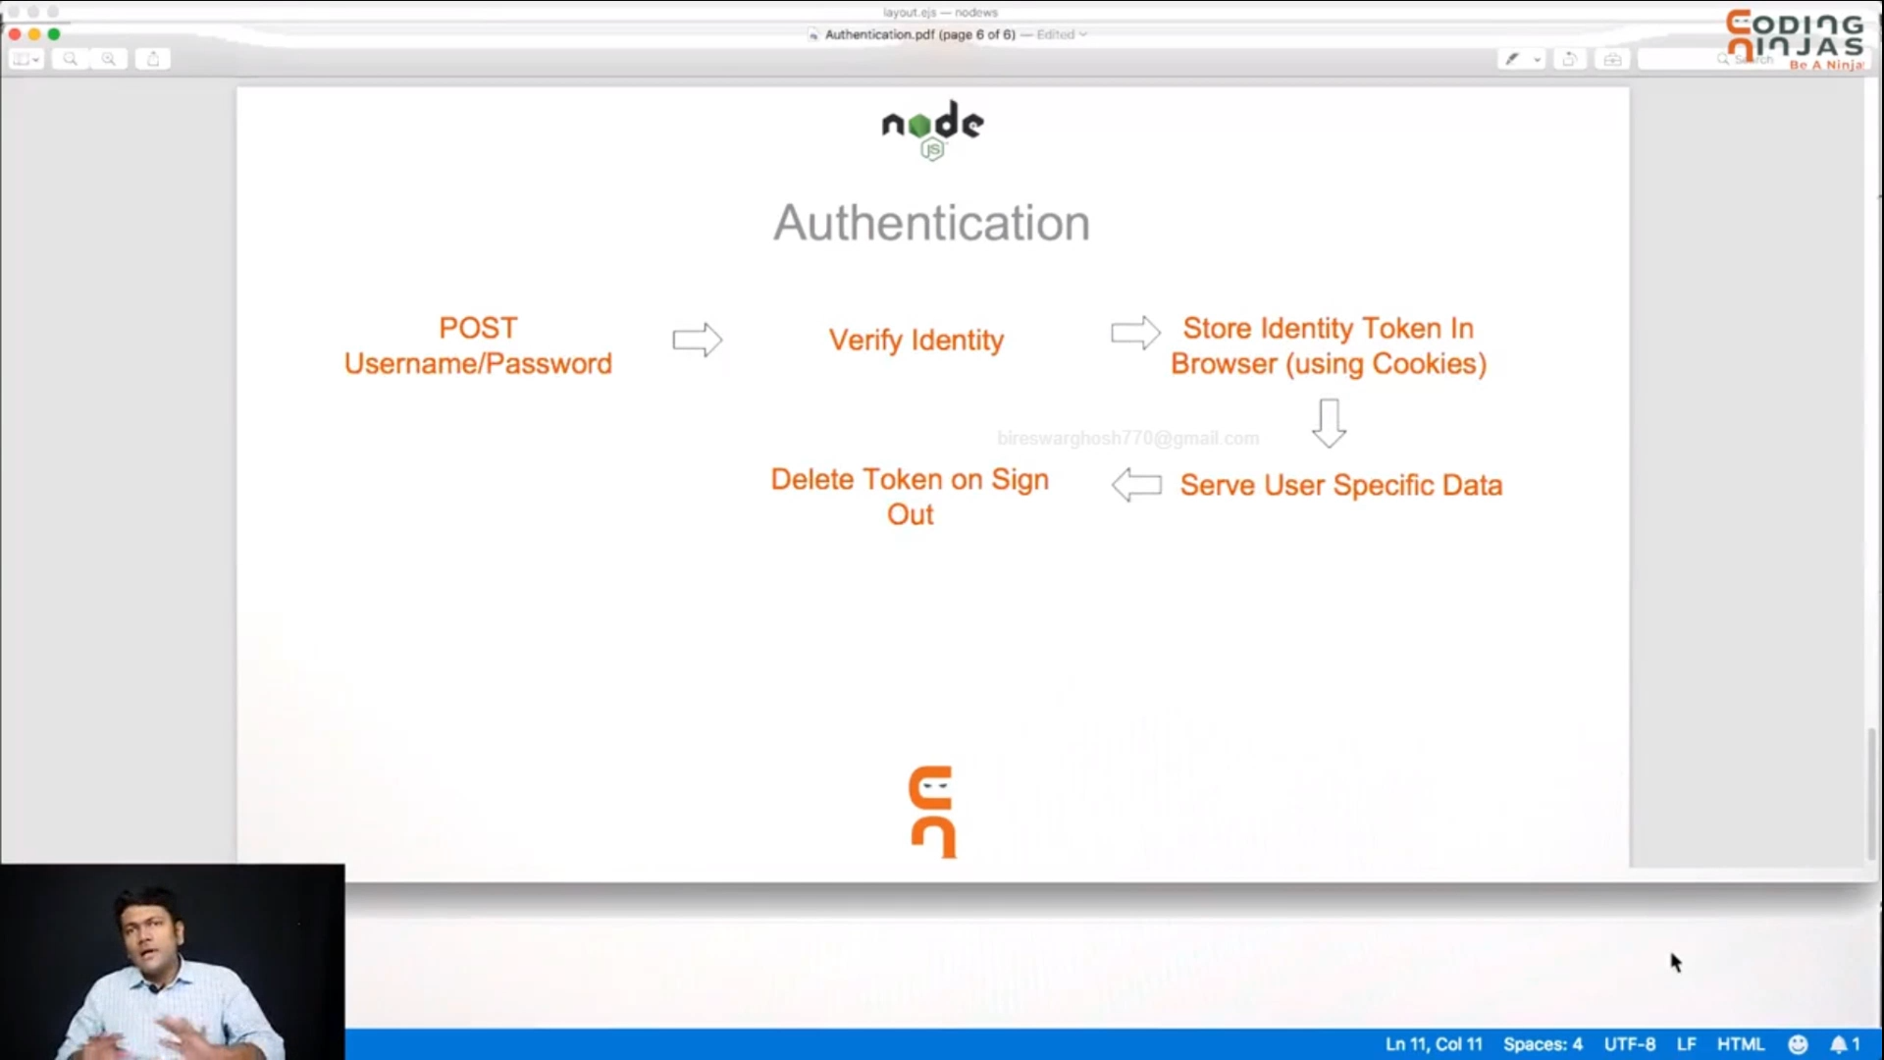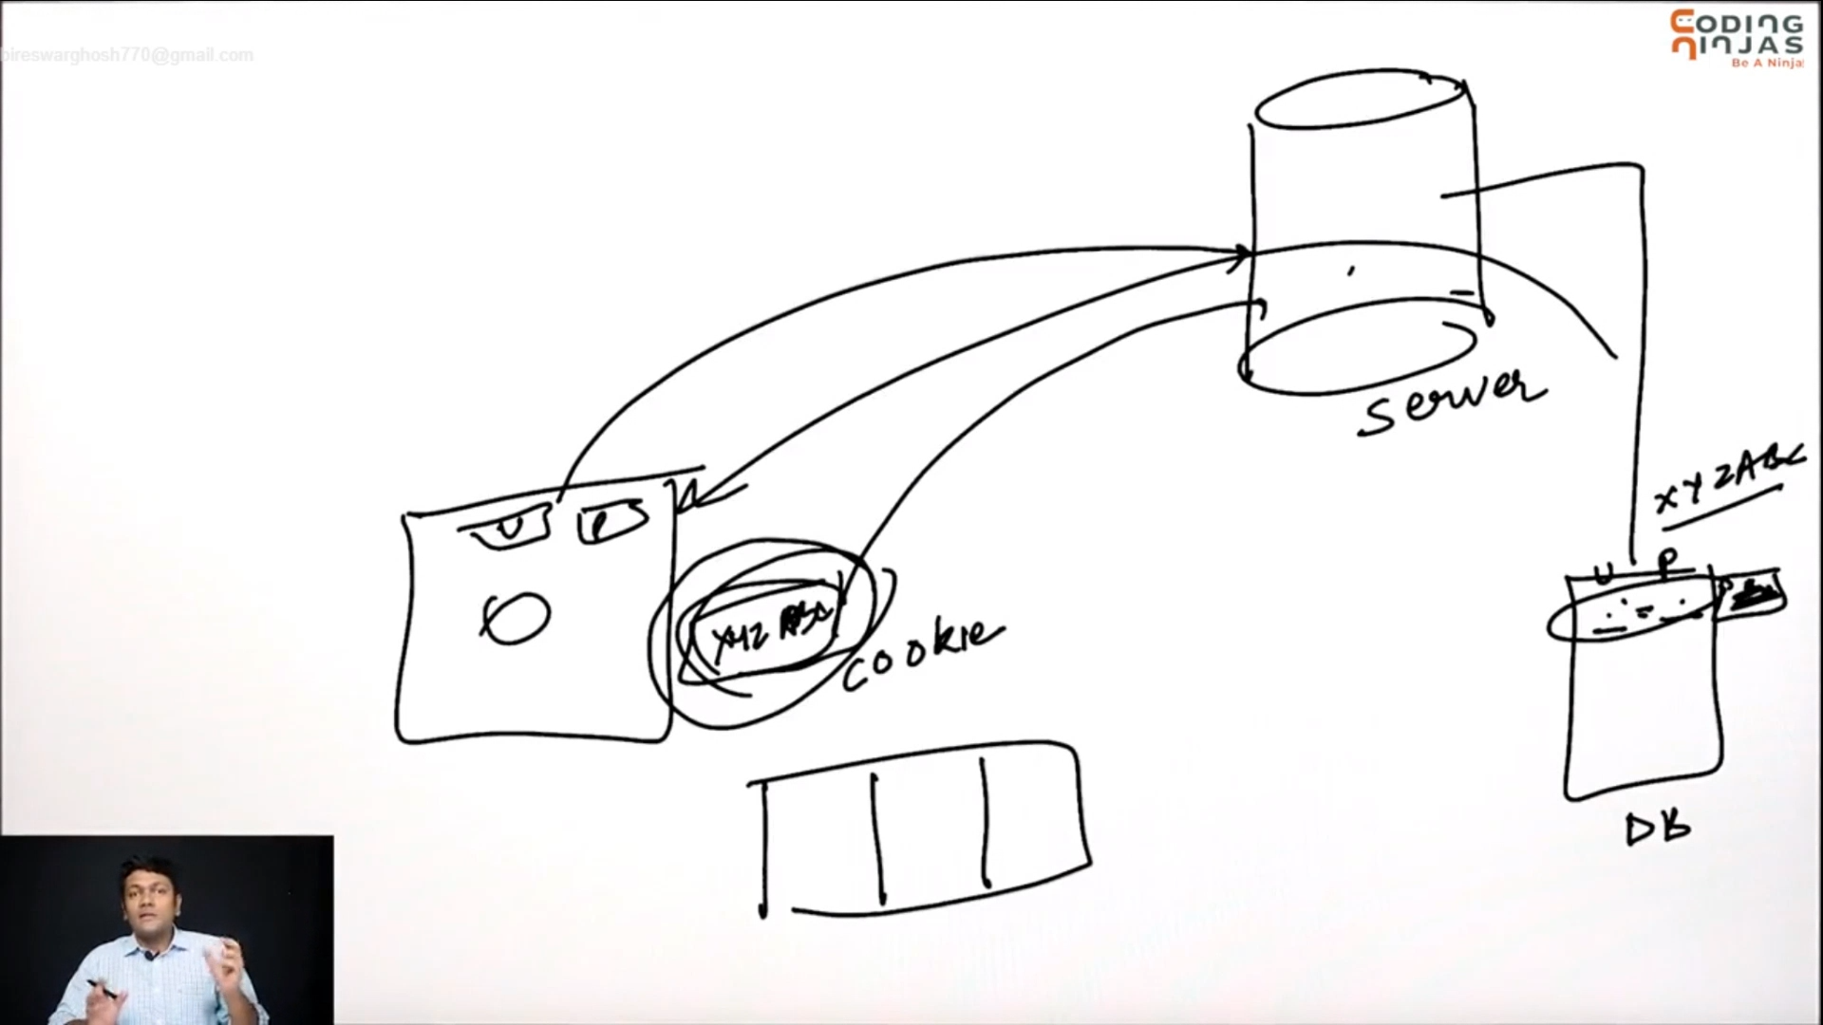

### step ---

1.

first of all hear creat models and under it

i creat a file (user.js) .

under this file we create a schema.

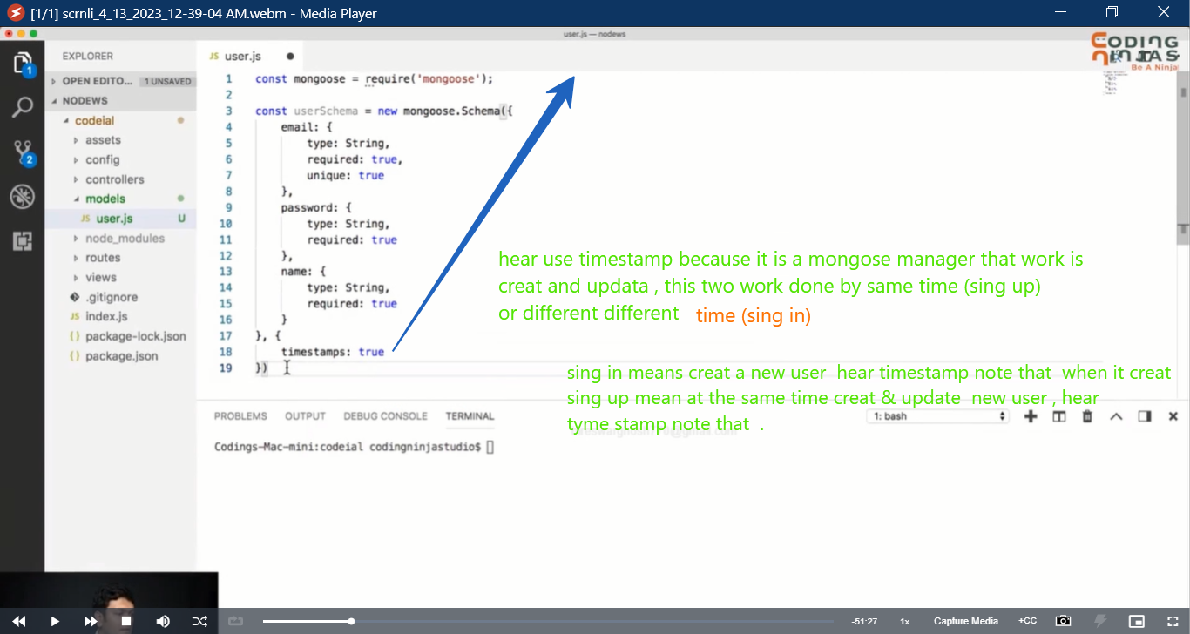

Now you add tow file like , user_sing_in & sing_up.

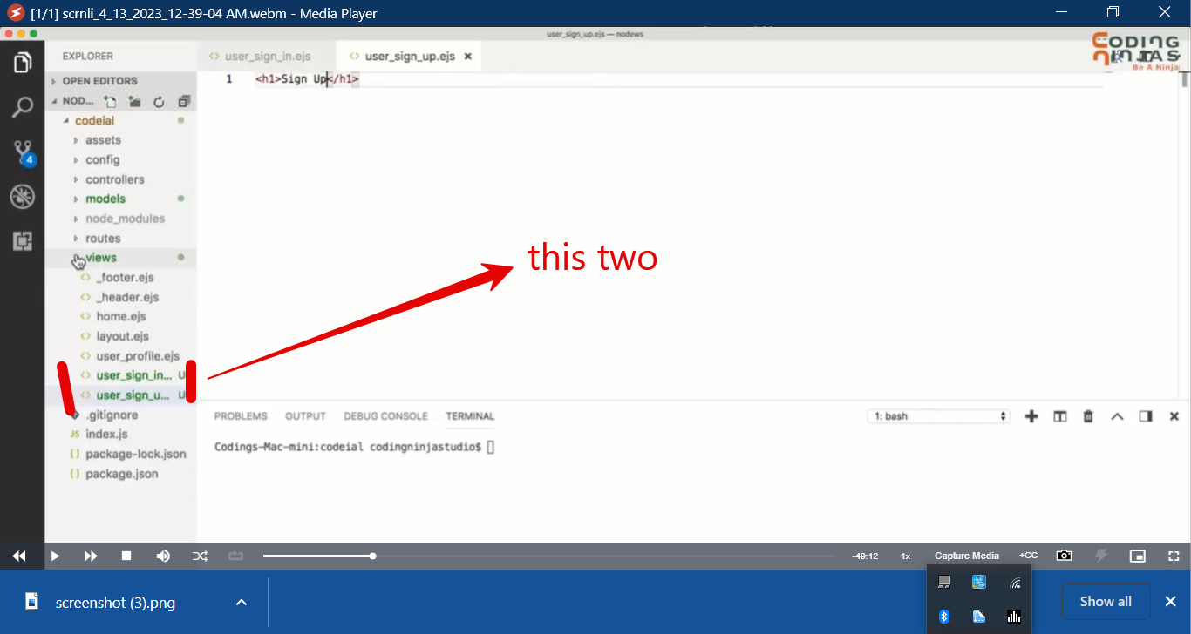

2 .

Now we goto controller folder

And go to user_controller file

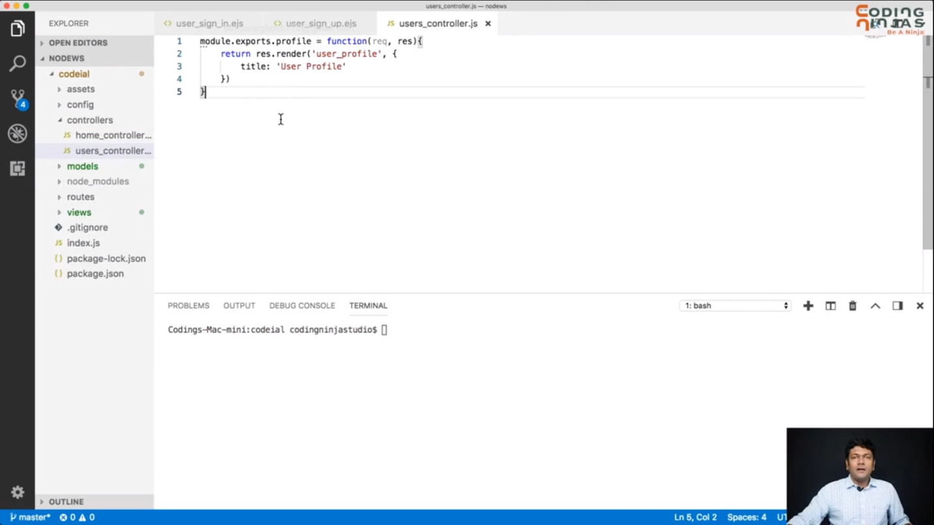

Now hear I add two different action that is

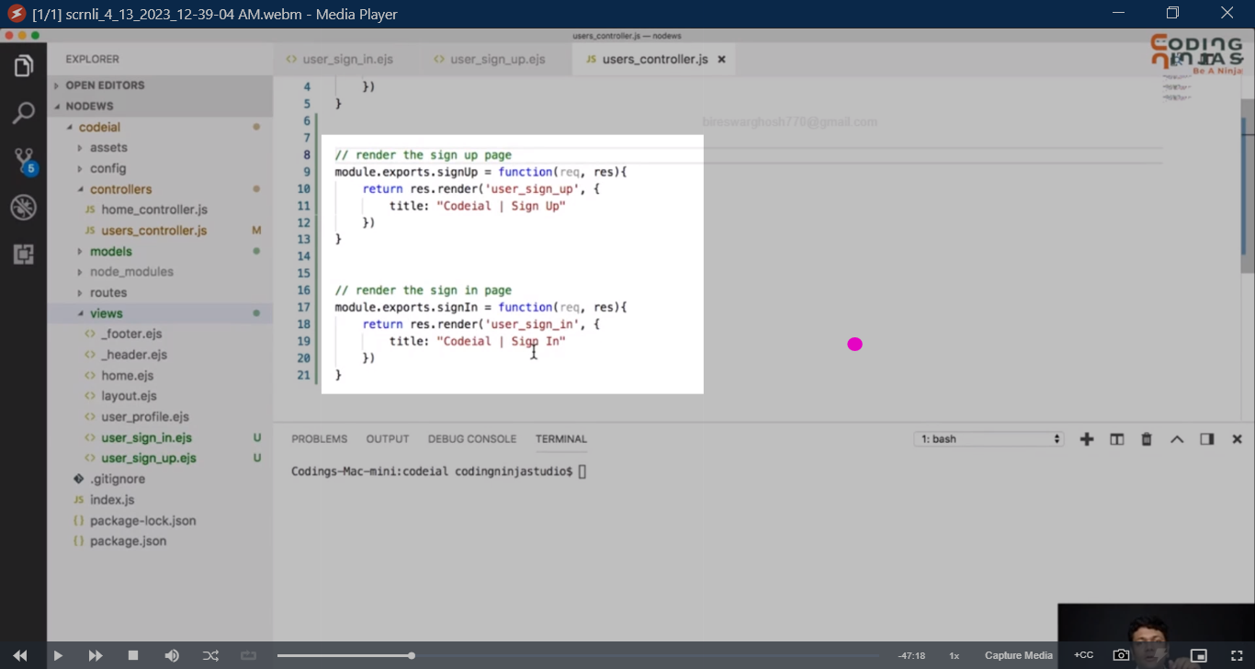

Now add it on router file user.js

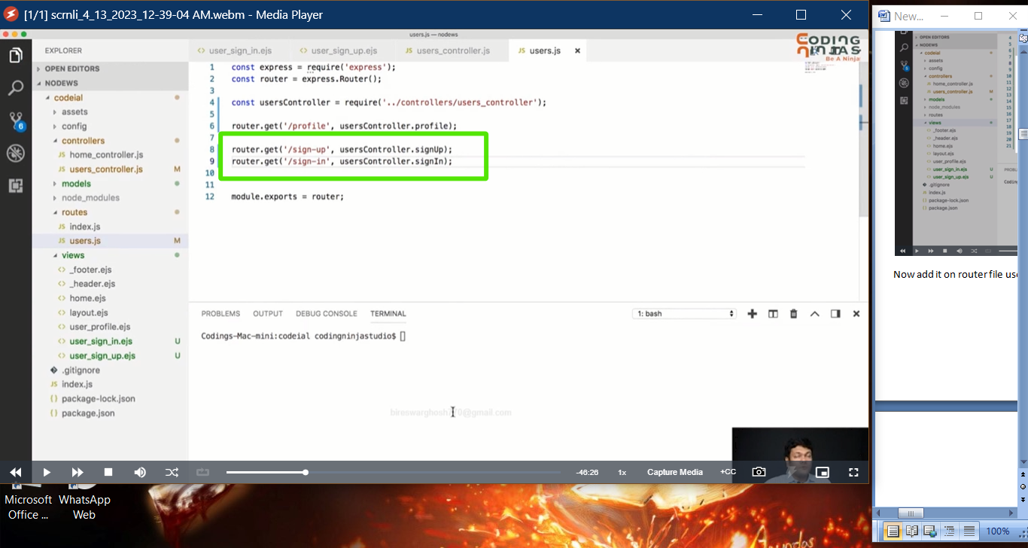

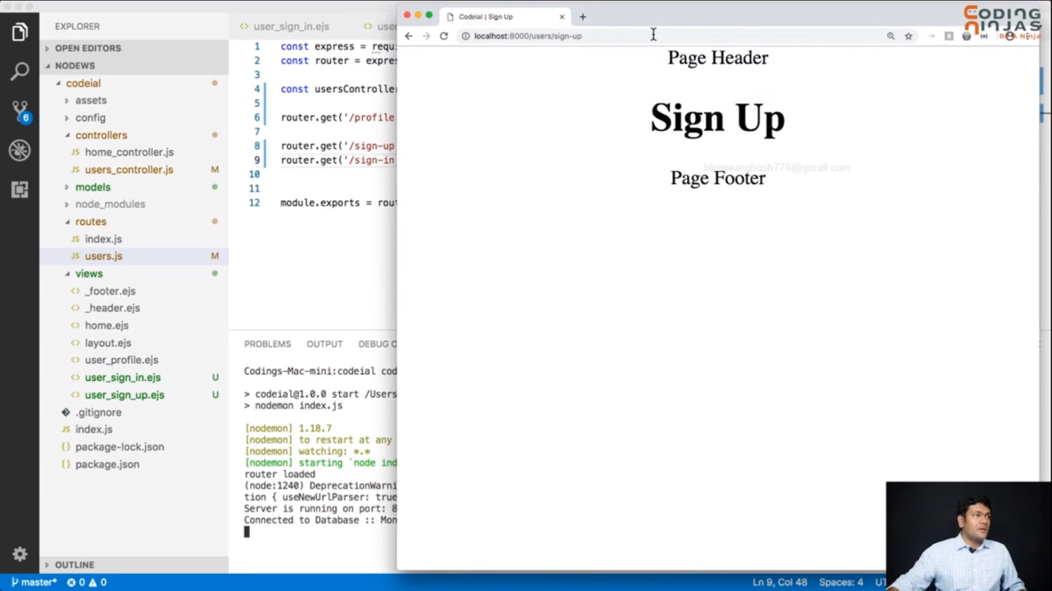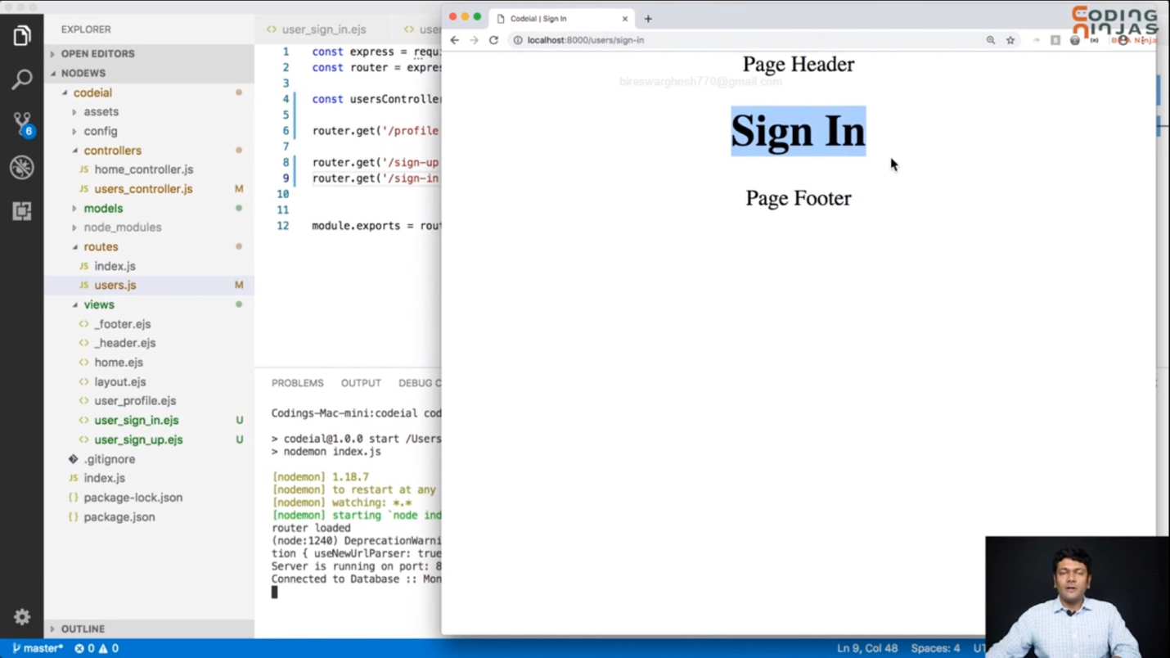

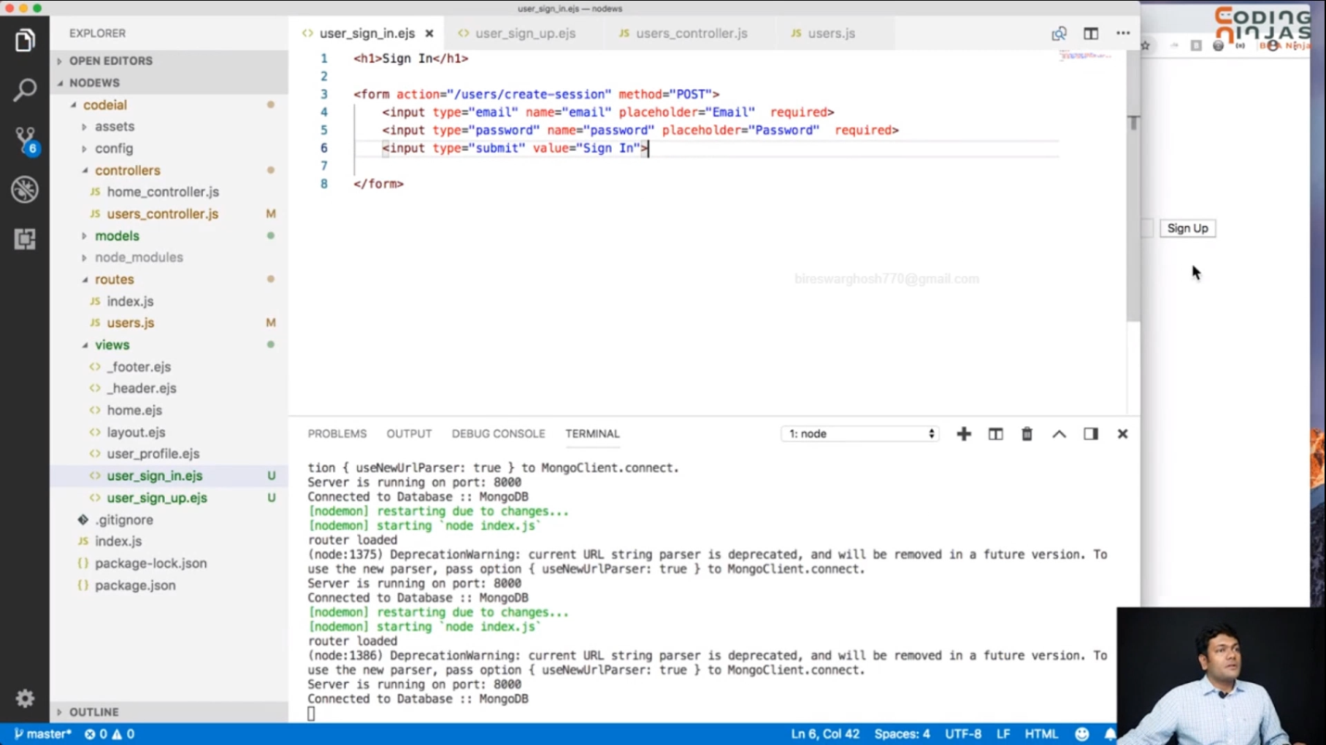

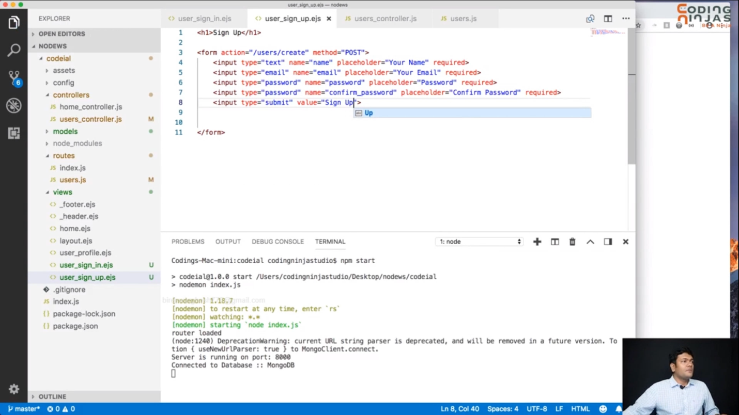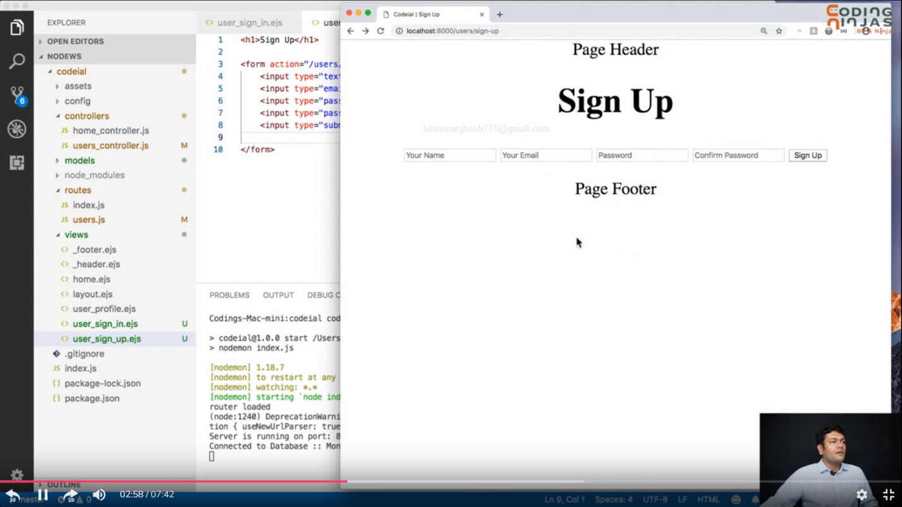

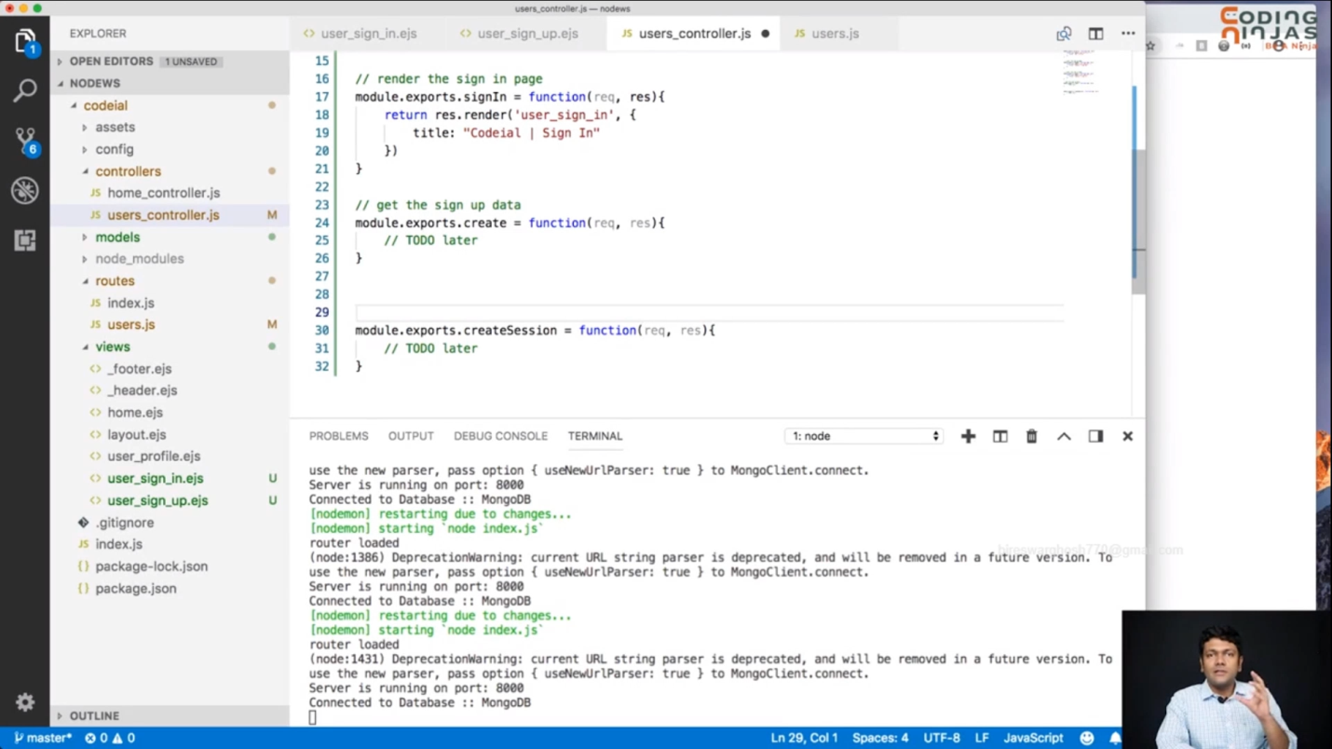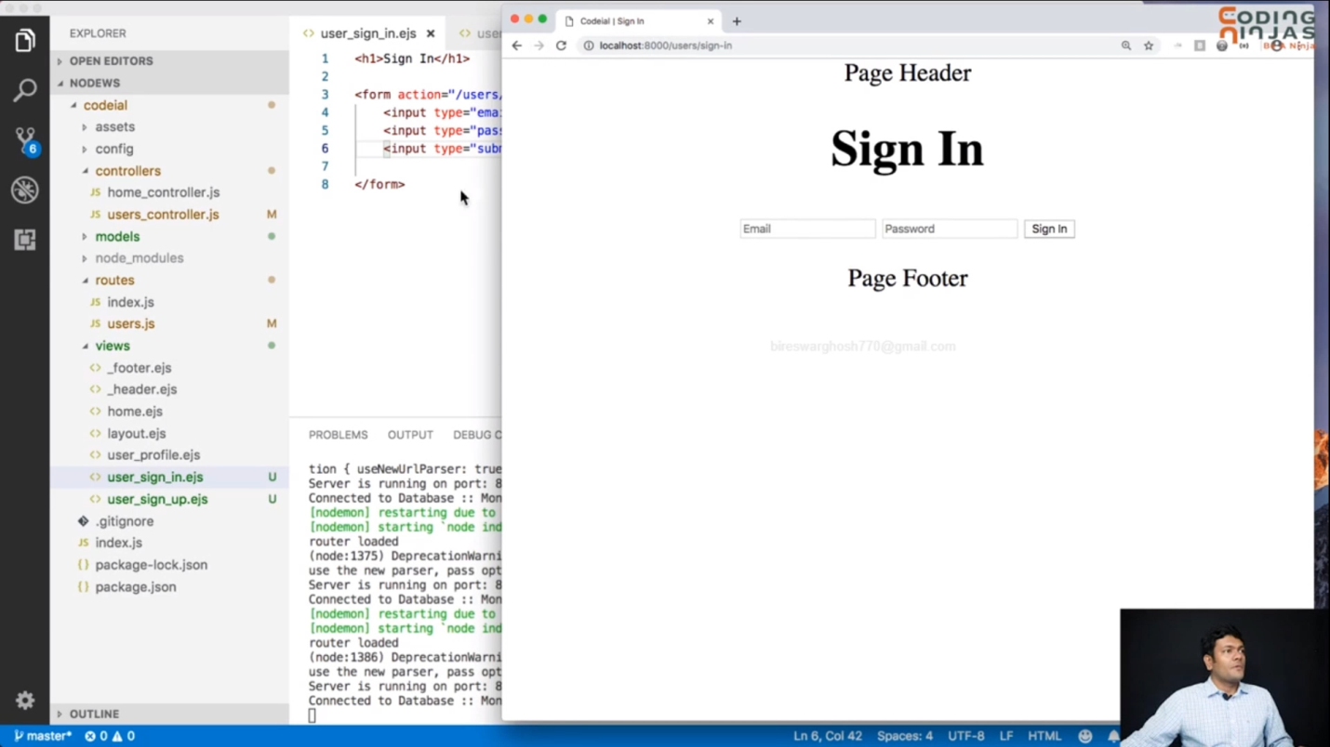

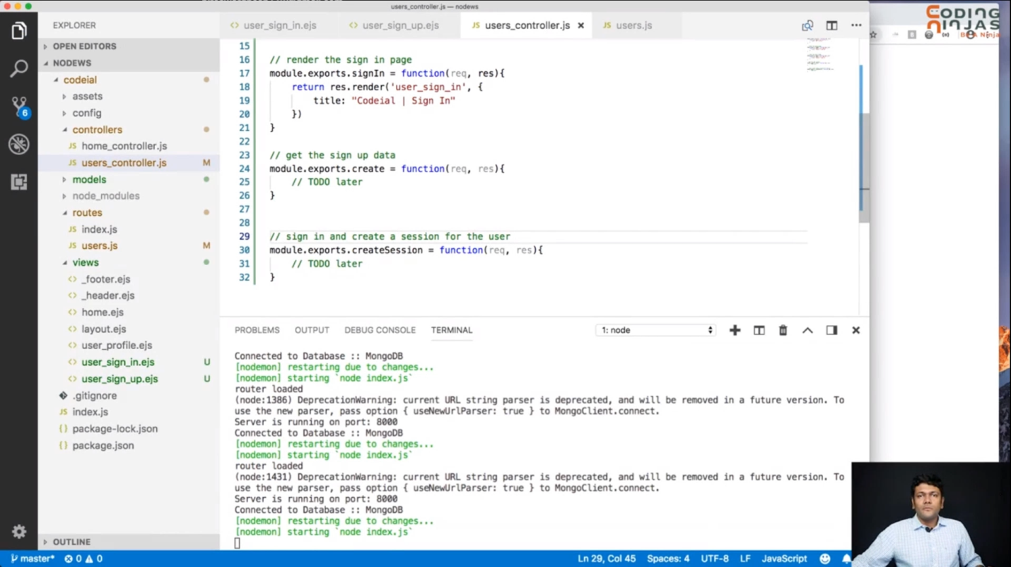 ***now till this point complet sing in or sing up complet***

***!!!!!!!! thamk you !!!!!!!!!!***

***Cookis***

***What is cookie ?***

***Cookie is the file that store by browser it send every req to server and server send the exact file to browser , it can eadaited by server or browser also . It used for to store data, or establish data. Or find device and many more.***

# C:\Users\AA\Downloads\screenshot (16).png C:\Users\AA\AppData\Local\Microsoft\Windows\INetCache\Content.Word\2023-05-09 01.09.38.png

To add add cookie-parser use line 2, and I tell the middelwear to use it ao add line 8 , and setting up the cookie parsers (10)

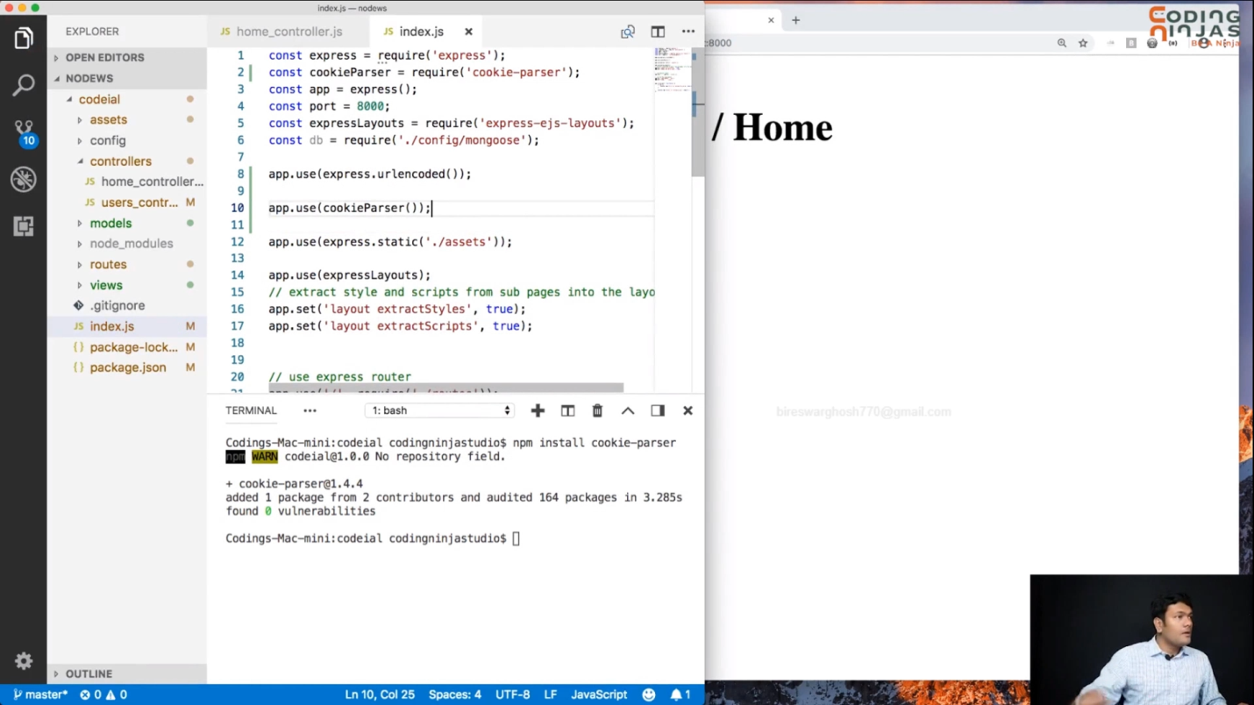

And start the server ,hear I see the where cookie is add

